

Cairo University
Faculty of Engineering
Electronics and Electrical Communications Engineering Department (EECE)
Fourth Year, First Term 2025/2026

Digital Signal Processing DSP (ELC4011)

DSP-1 Project-2 : Adaptive Energy Compaction & Spatial Entropy Mapping
Submitted to: Dr. Omar Nasr
Submission date: February13, 2026
NAME | SEC | ID
Ahmed Khalaf Mohamed Ali | 1 | 9220036
Yousef Khaled Omar Mahmoud | 4 | 9220984

Table of Contents
1 INTRODUCTION 5
2 Methodology 6
2.1 Preprocessing 7
2.2 Image Blocking 7
2.3 Block-wise 2D-DCT 7
2.4 Zigzag Scan 7
2.5 Adaptive Energy-Based Truncation 7
2.6 Reconstruction 7
3. Experimental Setup 8
4. Results & Visual Analysis 9
4.1 Original vs Reconstructed Images 9
4.2 Coefficient Heatmaps 11
4.3 Compressible vs Complex 14
4.4 Block Size Sensitivity 16
5. Discussion 18
5.1 Blocking Artifacts at Large Block Sizes (n = 32) 18
5.2 PSNR Degradation at Low T 18
5.3 Rate–Distortion Tradeoff 18
7. Conclusion 18

Project-2 : Adaptive Energy Compaction & Spatial Entropy Mapping
Ahmed Khalaf Mohamed Ali, Yousef Khaled Omar Mahmoud
Electronics and Communication Department, Faculty of Engineering, Cairo University Giza, 12613, Egypt
ahmed.ali031@eng-st.cu.edu.eg , youefkh05@gmail.com

INTRODUCTION

Digital image compression is a fundamental application of Digital Signal Processing (DSP), aiming to reduce data size while preserving perceptual quality. Transform-based compression techniques, particularly the Discrete Cosine Transform (DCT), are widely used due to their strong energy compaction properties.
In this project, an adaptive block-based DCT image compression system is implemented. Instead of retaining a fixed number of coefficients per block, an energy-targeted truncation strategy is employed. This allows dynamic adaptation to local image content, enabling efficient rate–distortion tradeoff analysis.

For implementation details, source code, results, analyses, and all plots, please refer to the project repository on GitHub [ link ].

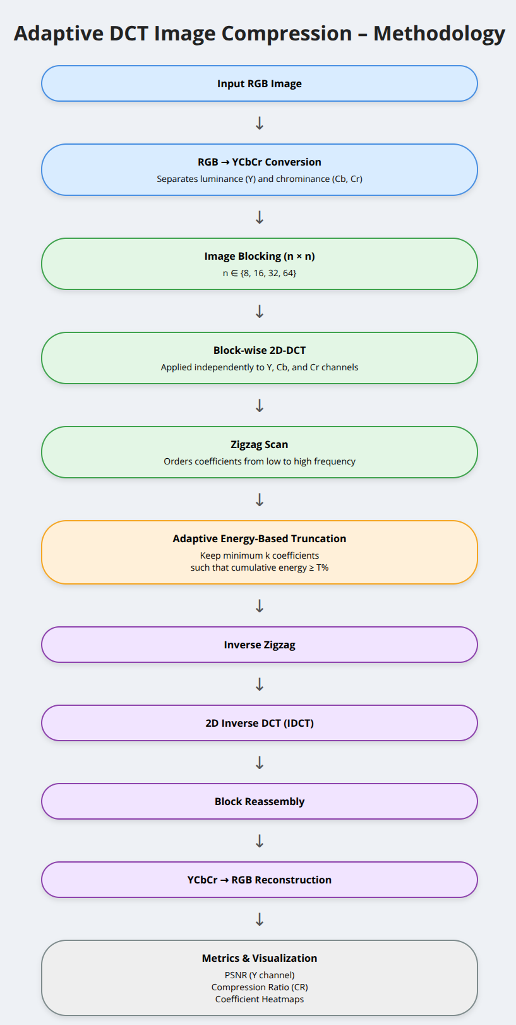
Methodology
Figure 1 methodology flow chart

From Figure 1,The implemented system follows the pipeline below:

2.1 Preprocessing

Each input image is converted to grayscale and normalized to the range $\left[0 , 255\right]$.
If the image dimensions are not divisible by the block size $n$, zero-padding is applied to ensure complete non-overlapping blocks.

2.2 Image Blocking
The image is partitioned into non-overlapping blocks of size $n×n$, where:
$$n∈\{8,16,32,64\}$$
This allows studying the impact of transform window size on compression performance.

2.3 Block-wise 2D-DCT
For each block, the 2D Discrete Cosine Transform is applied:
$$C=DCT_{2}(B)$$
The DCT transforms spatial pixel values into frequency coefficients, where low-frequency components typically carry most of the signal energy.

2.4 Zigzag Scan

Each $n×n$DCT coefficient matrix is converted into a 1D vector using zigzag scanning.
This ordering ensures coefficients are sorted from lowest to highest spatial frequency, which is crucial for efficient energy-based truncation.

2.5 Adaptive Energy-Based Truncation
Instead of keeping a fixed number of coefficients, an adaptive strategy is used:
- Total Energy Calculation
$$E_{total}=\sum_{i,j}{∣}C_{i,j}∣^{2}$$
- Cumulative Energy Accumulation
Coefficients are accumulated following zigzag order until:
$$E_{cum}≥T\%⋅E_{total}$$
where:
$$T∈[75\%,100\%]$$
- Coefficient Zeroing
All coefficients beyond the selected index $k$are set to zero.
- Metadata Recording
The value of $k$for each block is stored for heatmap visualization.

2.6 Reconstruction
The truncated DCT blocks are reconstructed using the inverse DCT:
$$\hat{B}=IDCT_{2}(C_{truncated})$$
The reconstructed blocks are then reassembled to form the final image.

3. Experimental Setup
Images: Four test images provided in the dataset
Block Sizes: $n=8,16,32,64$
Energy Thresholds: $T=75\%→100\%$
Metrics:
Compression Ratio (CR)
$$CR=\frac{\text{Total Pixels}}{∑k}$$
Peak Signal-to-Noise Ratio (PSNR)
$$PSNR=10{log⁡}_{10}\left(\frac{{255}^{2}}{MSE}\right)$$

4. Results & Visual Analysis

4.1 Original vs Reconstructed Images

At high values of $T$(e.g., 97–100%), reconstructed images closely resemble the original with minimal distortion as seen in Figure 2 through Figure 7.
At low values of $T$, high-frequency details such as edges and textures are progressively lost.


Figure 2: Original image 1 (RGB)

  Figure 3: Reconstructed image 1 with low T (T=75 %) |   Figure 4: Reconstructed image 1 with High T (T=99 %)

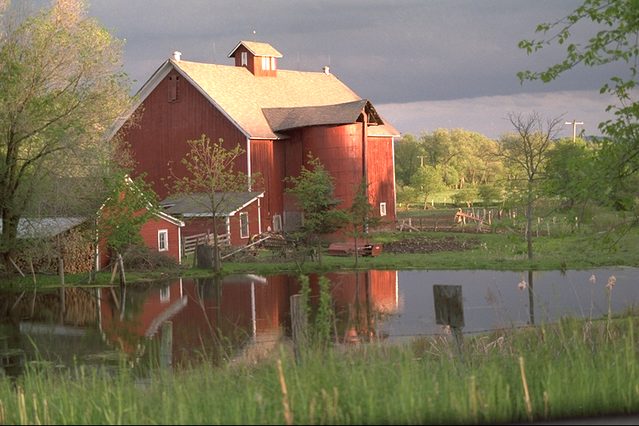
Figure 5 Original image 2 (RGB)

  Figure 6 Reconstructed image 2 with low T (T=75 %) |   Figure 7 Reconstructed image 2 with low T (T=99 %)

As $T$decreases, fewer DCT coefficients are retained in each block.
Because coefficients are accumulated in zigzag order, the discarded coefficients are mainly mid- and high-frequency components. These components represent sharp intensity transitions, edges, and fine textures.
Although high-frequency coefficients may carry small individual energy values, collectively they are essential for preserving structural detail.
When they are removed:
- Edge transitions become smoother.
- Fine textures disappear.
- Local contrast is reduced.
- Block boundaries may become more noticeable.
This increases the Mean Squared Error (MSE) between the original and reconstructed images.
Since PSNR is defined as:
$$PSNR=10{log⁡}_{10}\left(\frac{{255}^{2}}{MSE}\right)$$
An increase in MSE results in a logarithmic decrease in PSNR.
The drop becomes more significant at lower values of $T$ because:
- The first few retained coefficients capture most of the total energy.
- The remaining high-frequency components, though individually small, are numerous.
- Removing them introduces distributed pixel-level errors, especially around edges.
Therefore, the noticeable decrease in PSNR at low $T$ directly correlates with the visible loss of high-frequency details and reduced image sharpness.

4.2 Coefficient Heatmaps

From Figure 8 to Figure 15,Heatmaps illustrate the spatial distribution of the number of retained coefficients $k$for different energy thresholds $T$.
Observations when $T$is small (e.g., 75% - 84):
  - Fewer coefficients are needed to reach the required energy percentage.
  - Most of the energy is captured by the low-frequency DCT coefficients.
  - Smooth regions appear darker because the DC component and a few low-frequency terms are sufficient.
  - Textured and edge regions still require more coefficients, but overall $k$values remain relatively low.
Observations when $T$ is large (e.g., 95%–100%):
  - More coefficients must be retained to preserve a higher portion of total energy.
  - After low-frequency components are included, additional mid- and high-frequency coefficients are required.
  - Heatmaps become brighter overall, especially in detailed regions.
  - Edge-dense and textured areas show a significant increase in $k$, reflecting their higher frequency content.
This behavior confirms the energy compaction property of the DCT and demonstrates that the adaptive method dynamically allocates more coefficients to complex regions while keeping smooth regions highly compressible.

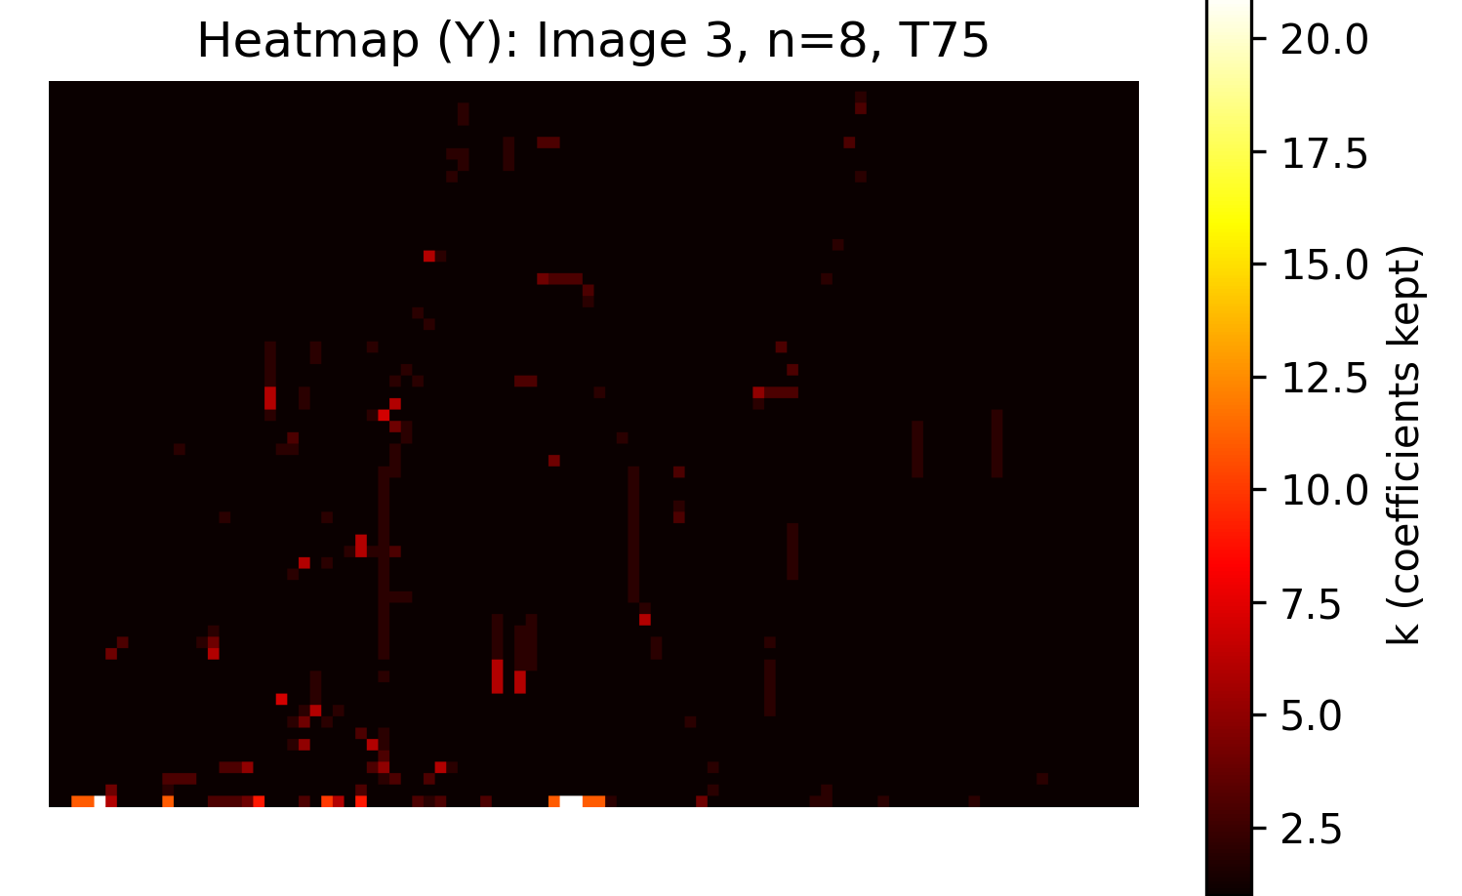
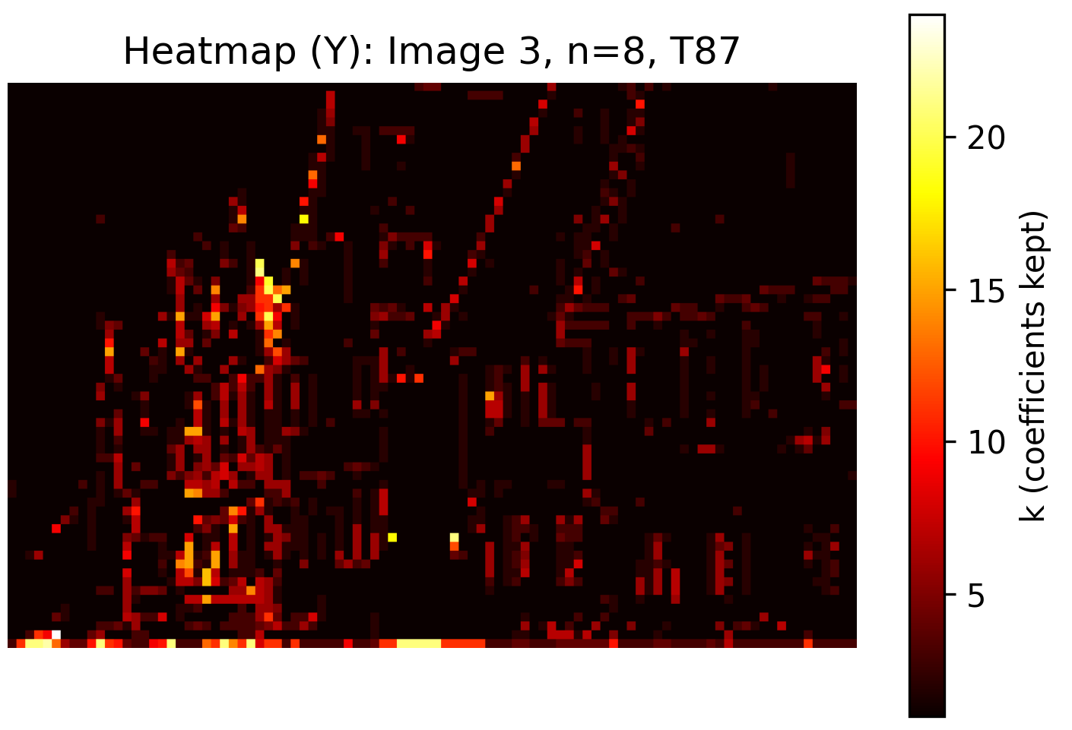

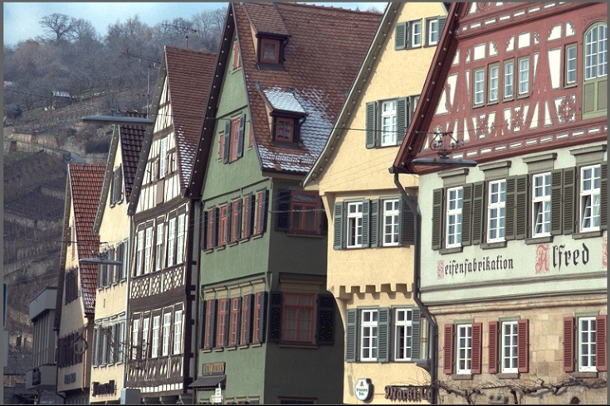
Figure 8:Heatmap for the third image with low T (T = 75 %) Figure 9: Heatmap for the third image with medium T (T = 87 %)
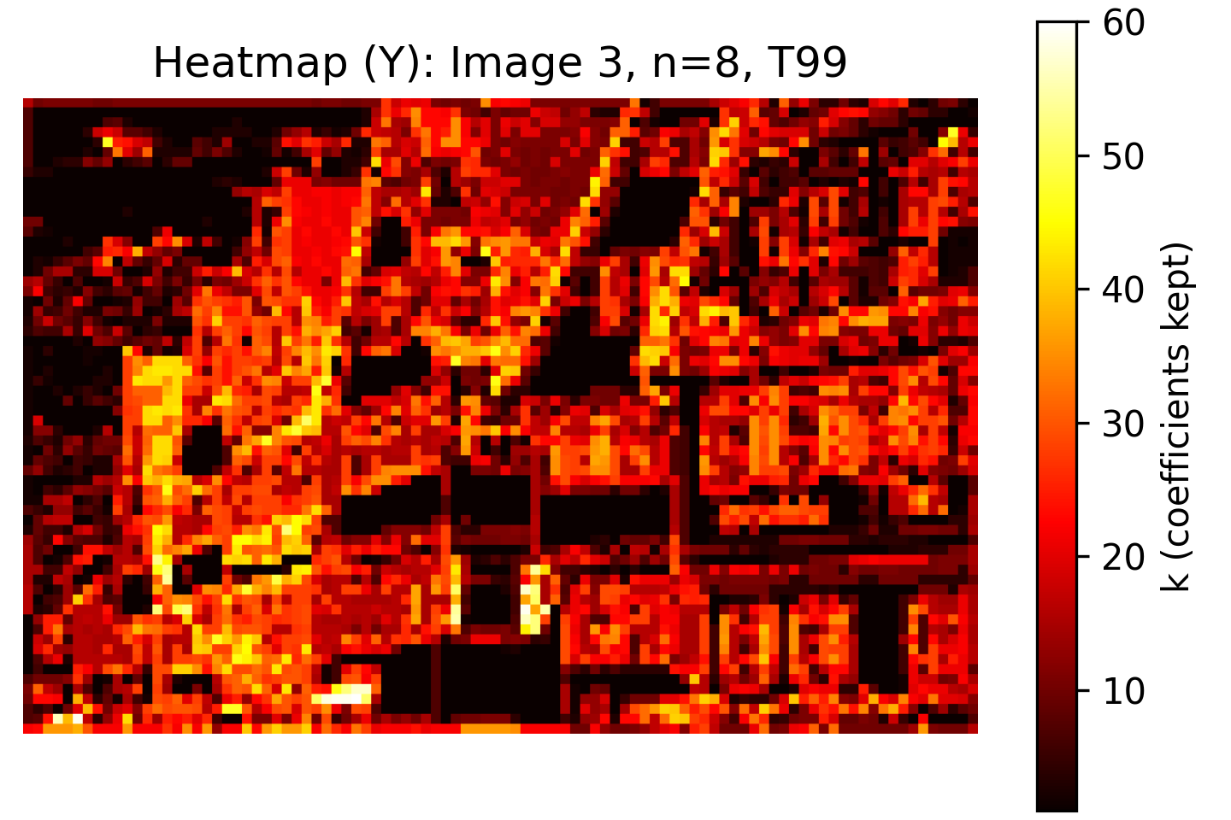
Figure 11: Heatmap for the first image with high T (T = 99 %)
Figure 10 Original third image


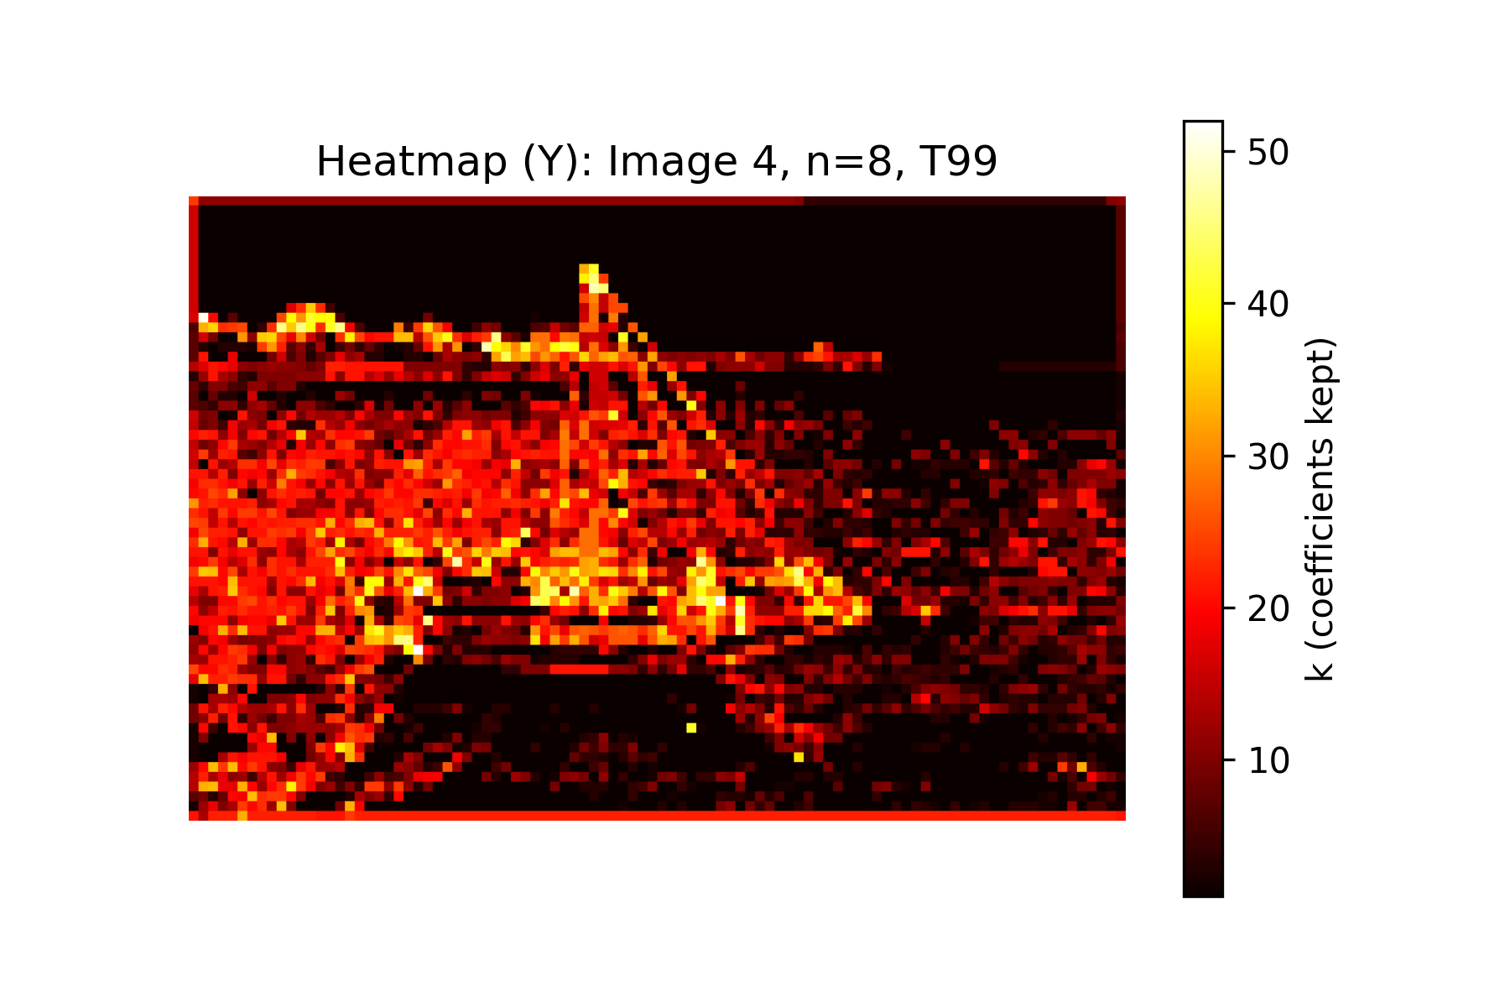
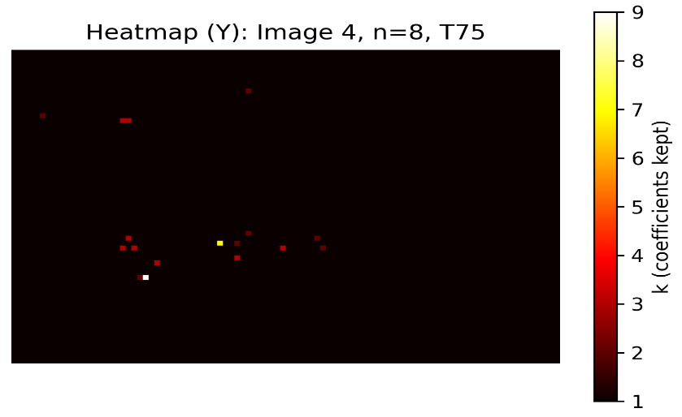
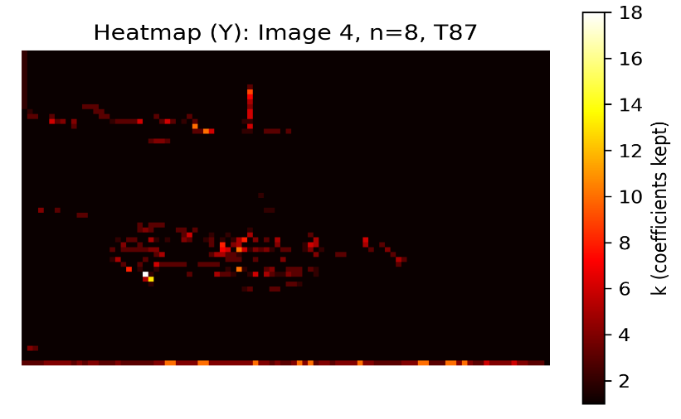
Figure 12 Fourth original image
Figure 13 Heatmap for the fourth image with medium T (T = 87 %)
Figure 14 Heatmap for the fourth image with low T (T = 75 %)
Figure 15: Heatmap for the fourth image with high T (T = 99 %)

4.3 Compressible vs Complex

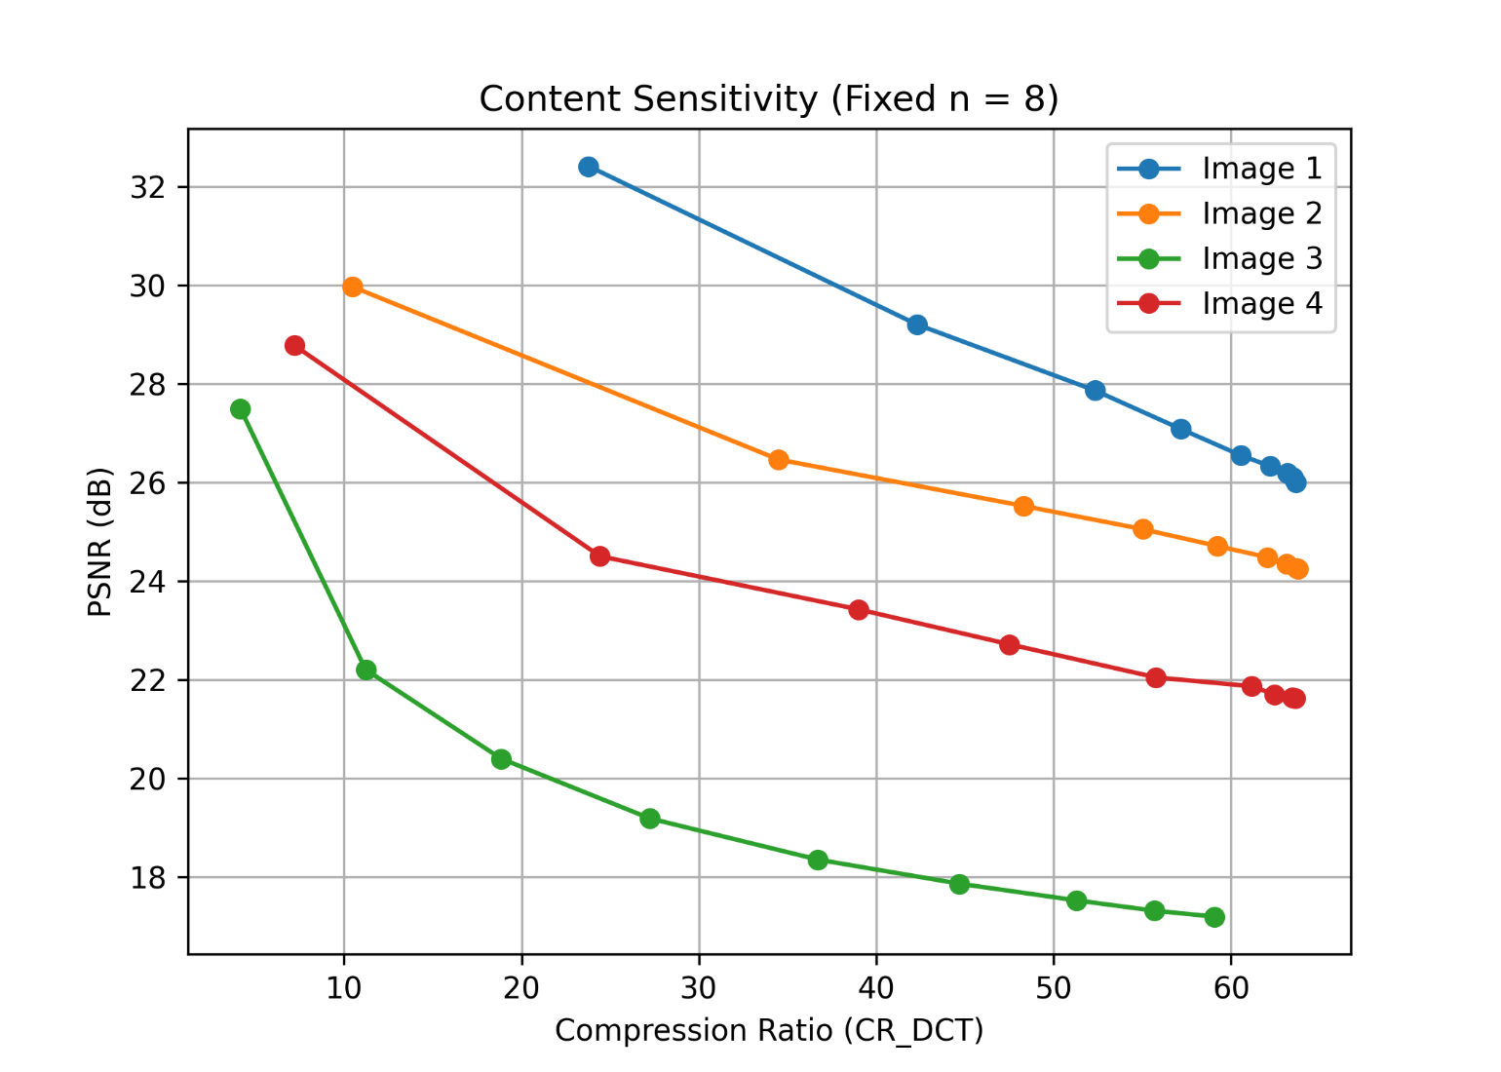
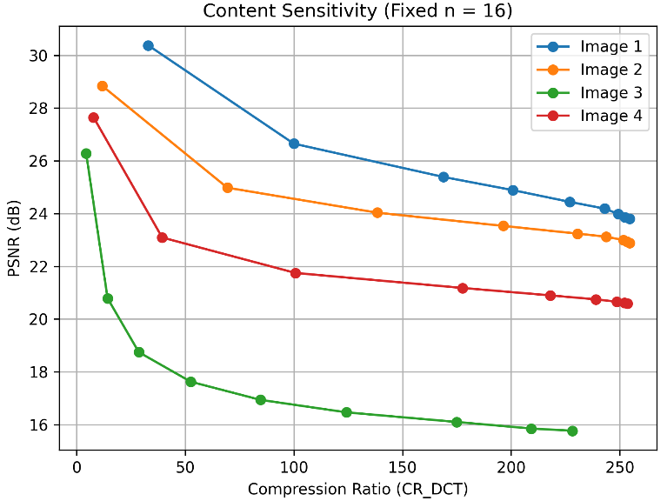
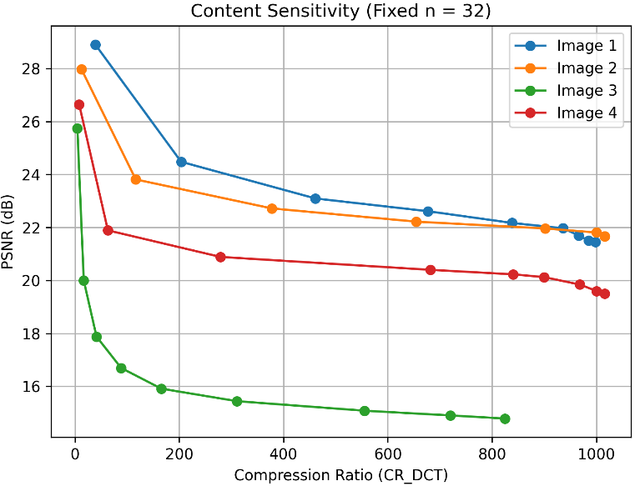
Figure 18: PSNR versus Compression Ratio for Different Images (n = 8)
Figure 16 PSNR versus Compression Ratio for Different Images (n = 32)
Figure 17 PSNR versus Compression Ratio for Different Images (n = 16)

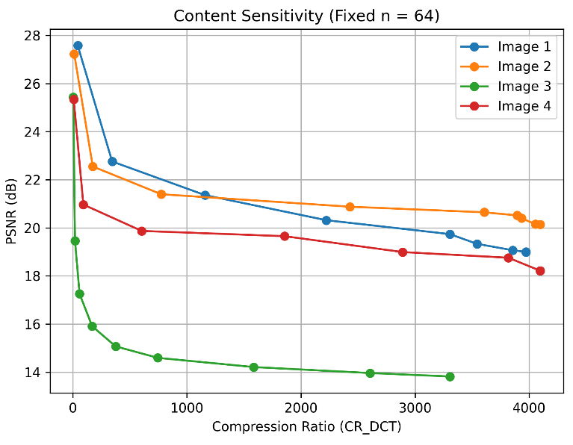
Figure 19 PSNR versus Compression Ratio for Different Images (n = 64)
This plot shows PSNR versus Compression Ratio for four images using 8×8 blocks. PSNR decreases as compression increases, confirming the expected rate–distortion tradeoff. Image 1 consistently achieves the highest PSNR, indicating it is the most compressible, while Image 3 shows the lowest PSNR, reflecting high structural complexity. The differences in curve slopes highlight that compression efficiency strongly depends on image content, with smoother regions retaining quality better than highly textured ones with results summarized in Table 1.
Table 1 Complex vs Compressible summary
Image | Observed Behavior | Classification | Explanation
Image 1 | High PSNR maintained as CR increases for all n | Compressible | Dominated by smooth regions; energy concentrated in low frequencies
Image 2 | Moderate PSNR drop with increasing CR | Moderately Complex | Contains edges but still large smooth areas
Image 3 | Rapid PSNR degradation even at low CR | Complex | Rich textures and high-frequency details require many coefficients
Image 4 | PSNR between Image 2 and 3 | Moderately Complex | Mix of smooth regions and textured structures

As shown in Figure 16 to Figure 19, they illustrate the content sensitivity of the adaptive DCT compression scheme for increasing block sizes. As the block size increases, higher compression ratios are achieved due to improved energy compaction; however, this comes at the cost of reduced PSNR. Smooth images remain highly compressible across all block sizes, while images with rich textures and edges experience rapid quality degradation. This behavior highlights the trade-off between compression efficiency and spatial adaptability inherent in block-based transform coding which is summarized in Table 2.

Table 2 Effect of n increasing
Block Size n | Effect on CR | Effect on PSNR | Interpretation
8 | Lowest CR | Highest PSNR | Best local adaptation, least blocking
16 | Moderate CR | Slight PSNR loss | Good balance between quality and compression
32 | High CR | Noticeable PSNR loss | Larger blocks fail to capture local detail
64 | Highest CR | Lowest PSNR | Strong blocking artifacts, poor edge preservation

4.4 Block Size Sensitivity

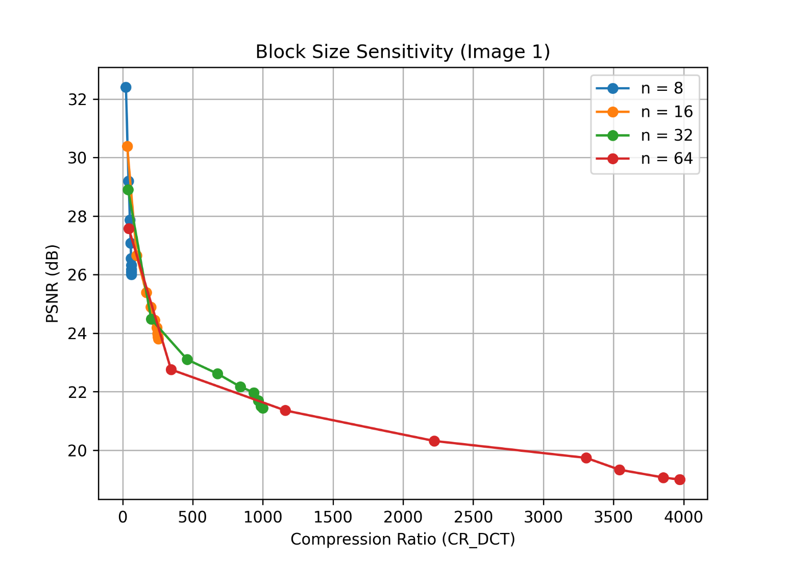
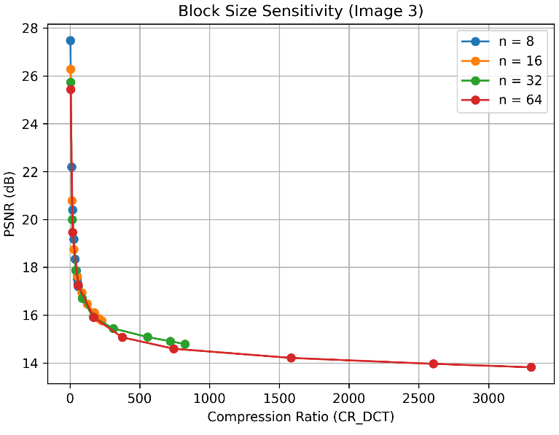
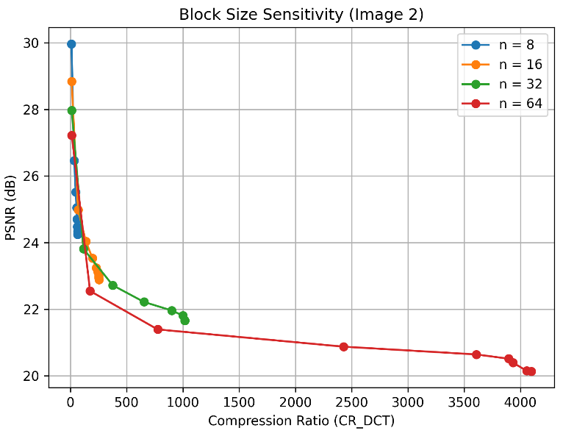
Figure 22: PSNR versus Compression Ratio for Different Block Sizes image 1
Figure 20 PSNR versus Compression Ratio for Different Block Sizes image 3
Figure 21 PSNR versus Compression Ratio for Different Block Sizes image 2
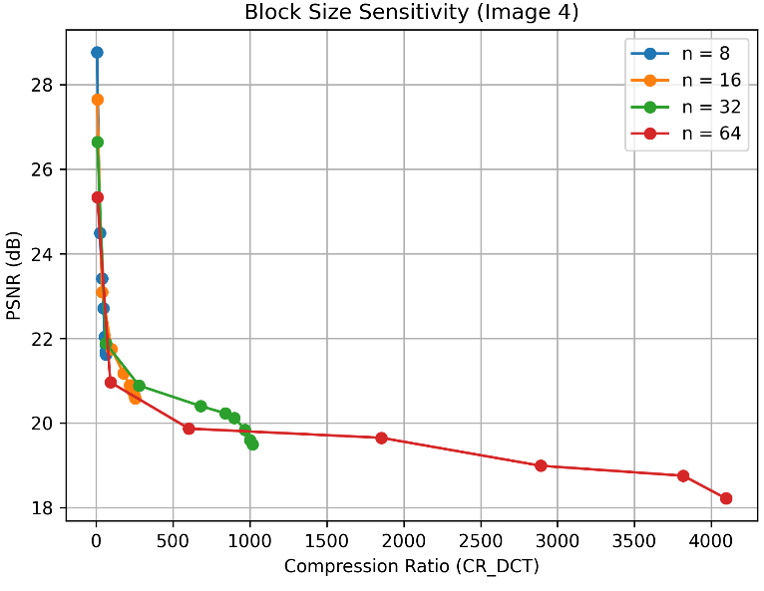
Figure 23 PSNR versus Compression Ratio for Different Block Sizes image 4
Figure 8 illustrates the effect of block size on compression performance for a single image. Smaller blocks (e.g., 8×8) provide better preservation of fine details, resulting in higher PSNR at low compression ratios, while larger blocks (e.g., 32×32, 64×64) achieve higher energy compaction but may blur edges and textures, reducing PSNR. The curves clearly show the tradeoff between block size, compression efficiency, and reconstruction quality.

5. Discussion

5.1 Blocking Artifacts at Large Block Sizes (n = 32)

Blocking artifacts become more prominent at larger block sizes due to:
Loss of high-frequency continuity across block boundaries
Larger spatial regions being approximated by fewer dominant frequencies
Independent processing of blocks without overlap
In contrast, smaller blocks (e.g., $n=4$or $n=8$) localize errors, reducing visible discontinuities.

5.2 PSNR Degradation at Low T

As the energy threshold $T$decreases:
Fewer high-frequency coefficients are retained
Edge sharpness and fine textures are lost
Mean Squared Error (MSE) increases significantly
Since PSNR is inversely proportional to MSE, even small losses in high-frequency detail lead to a sharp drop in PSNR.
This behavior is strongly correlated with the visual blurring observed in reconstructed images.

5.3 Rate–Distortion Tradeoff

Master plots demonstrate a clear tradeoff:
Higher Compression Ratio → Lower PSNR
Smooth images achieve higher PSNR at the same CR compared to textured images
Smaller block sizes generally provide smoother rate–distortion curves

7. Conclusion
This project demonstrates the effectiveness of adaptive energy-based DCT compression. The results confirm that:
The DCT provides strong energy compaction
Adaptive truncation efficiently responds to local image complexity
Heatmaps offer intuitive visualization of spatial entropy
There exists a fundamental tradeoff between compression efficiency and perceptual quality
The system successfully integrates DSP theory with practical implementation and visual analysis

